Post-Graduation Problem: Resilient Basing and Agile Combat Employment

# Introduction

The security environment for the United States (US) has dramatically changed in the last 30 years, and this is largely due to China and Russia’s rapid expansion of military weapon systems and tactics. These capabilities are designed to damage or destroy fixed facilities and assets (Lynch et al., 2023) . In response, the US and its growing consensus of the significant threat that China and Russia pose, has created a call for action to counter these threats. To address these concerns, The US Secretary of the Air Force list seven operational imperatives to reconfigure the United States Air Force (USAF) and Space Force (USSF) (Pope, 2022).

In this research, we focus on the resilient basing imperative in the Indo-Pacific region, which builds on a concept known as Agile Combat Employment (ACE). ACE converts a fixed airfield strategy into a more flexible posture that provides greater mobility by using clusters of locations, which makes targeting major assets more difficult (Lynch et al., 2023) . This derives the question of what investments and strategies does the Department of Defense (DOD) need to employ to mix defenses, hardening, deception and proliferation. In the interest of this research, we focus on determining the value utilizing deception tactics (i.e., decoys).

Deception in a military context aims to deliberately induce misperception in another for tactical, operational or strategic advantage (Gerwehr & Glenn, 2000) . Gerwehr et al. in their study of deception highlights the importance of decoys and their ability to feint to deflect enemy attention. What might the value of playing shell game with fighter aircraft and decoys?

# (Alternate) Intro

Department of the Air Force Operational Imperative Five lays out a challenge to the US Air Force to develop a plan to cost-effectively counter the threat of Chinese Long Range Precision Missiles (LRPM) on Fixed Forward Airbases. The Air Force relies on these locations for power projection and reassurance of regional allies to the United States and the threat of missile attack on these locations have geopolitical consequences.

The Air Force has decided to adopt Agile Combat Employment (ACE) as an operating concept to counter the Chinese LRPM Threat. The idea is that air forces are agile enough to vary their basing location (including austere locations), such that Chinese ability to locate and target air platforms is degraded to the point where LRPM is not able to be effectively employed.

The Air Force calls for a mix of active and passive measures that increase the resiliency of the existing forward bases while enabling the generation of sorties from distributed, and perhaps even austere locations.

# The Problem

The realization of ACE requires a number of costly investments in mission command, logistics, prepositioned supplies, and the additional training of airmen. There is likely a number of years before the concept can be fully realized to the point of effectiveness.

Similarly, existing Air Defense systems are likely not as capable against newer missile types such as hypersonic glide vehicles and hypersonic cruise missiles. They are also expensive and vulnerable to attack themselves. Acquisition of new Air Defense Systems is expensive and time-consuming. Research, Design, and Acquisition of new Air Defense Systems able to counter the hypersonic threat is likely even more expensive and further away on the time horizon.

Passive measures are likely the cheapest and easiest to implement. Though there are limits to the effectiveness of passive measures, these solutions have the greatest potential of being implemented at scale in a few years, for a comparatively cheap amount, on a short time scale.

Given the above, this research seeks to characterize the overall problem of resilient basing. Then, a specific passive measure will be explored. The passive measure to be explored will be the concept of playing shell-game on a single fixed forward airbase. A Shell-game is a game where 3 or more shells are placed face-down with a prize hidden underneath one of the shells. The objective is for the player to guess under which shell lies the prize. In this conception, the Air Force hides its aircraft underneath “shells” and the Chinese guess under which shells aircraft are hidden by launching missiles at the shells.

The analogy works when one thinks of the possible types of shelters that can be constructed on the airbases as shells under which aircraft can be hidden. Extending this analogy, one can also purchase and deploy decoys or false prizes. Decoys and aircraft can be hidden or not hidden underneath a shelter.

# Cost Estimate and Capability Evaluations

In order to understand the monetary impact for decision makers there needs to be proper evaluation of several cost estimates. The four key estimates we evaluate are: 1.) aircraft protective shelters, 2.) air defense systems and their missiles, 3.) fighter aircraft, and 4.) decoys.

The three shelter variations that contribute to aircraft protection are the hardened aircraft shelters (HAS), protective aircraft shelters (PAS), and deployable shelters. The HAS serves as housing for fighter aircraft and can withstand anywhere from 200 to 500+ pounds per square feet (PSI). The next capable shelter, the PAS, offers less protection and can withstand 50-200 PSI. Lastly, the deployable shelter is Kevlar lined which provides moderate protection from bomblet debris and can withstand less than 50 PSI. The volatility of resources, research of past shelter cost estimates and the inclusion of an inflation factor produces cost estimates presented in Table 1.

The three air defense systems observed for this research and highly utilized in modern day surface-to-air defense if the national advanced surface-to-air missile system (NASAMS), the terminal high altitude area defense (THAAD) system, and the phased array tracking radar to intercept on target (PATRIOT). NASAMS the more affordable option, is a highly adaptable mid-range air defense solution (Arabia, 2022), whereas THAAD is a highly effective combat defense against short, medium, and intermediate-range ballistic missile threats that is designed to intercept targets outside and inside the atmosphere (*THAAD Proven Integrated Air and Missile Defense*, n.d.). The cost for the NASAMS and THAAD air defense systems, as well as their associated missile cost is represented in Table 1.

In this research, three fighter aircraft are observed: the F-22, F-16, and F-15. The most utilized aircraft in the USAF fleet is the F-16 which is primarily due to its affordability in comparison to varying aircraft. We focus on the effect decision making in relation to these aircraft because of their popularity and fifth-generation capability, thus, we include their cost estimates from previous literature. The use of the F-22, F-16, and F-15 is also motivated by the modern development of fighter aircraft decoys. A visual representation of these decoys can be observed in Figures 1, 2, and 3 (*Inflatable Military Aircraft*, n.d.).

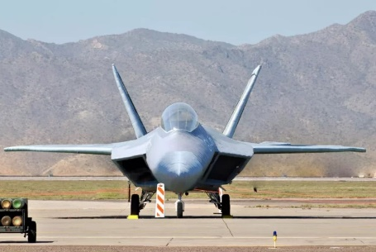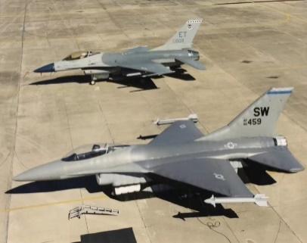 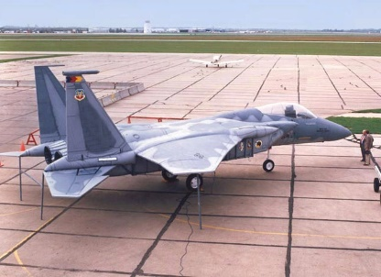

Figure 1: F-22 Decoy Figure 2: F-16 Decoy Figure 3: F-15 Decoy

The ability of modern-day technology to incorporate different sensory and visual deception techniques further supports the viability of utilizing more affordable options, such as fighter aircraft decoys. The cost estimates for the fighter aircraft and their associated decoys are presented in Table 1.

|  |  |
| --- | --- |
| System | Cost FY23$ |
| HAS | 7.2 |
| PAS | 3.6 |
| Deployable Shelter | 0.4 |
| NASAMS (Missiles) | 23 (1.3) |
| THAAD (Missiles) | 800 (2) |
| PATRIOT (Missiles) |  |
| F-22 (Decoy) |  |
| F-16 (Decoy) |  |

# The Solution Space

The Solution Space that counters the threat of Chinese LRPM can be characterized by the 3 characteristics: Low-Cost Solutions, Joint/Multi-National Solutions, and “Flexible” Solutions.

Low-Cost Solutions are the set of possible solutions that can be attained without significant capital investment. An example of this might standing up a rapid runway repair team to mitigate damage from an attack as opposed with purchasing a new Air Defense platform.

Joint/Multination Solutions are characterized by the increased cooperation between the Air Force and sister services, as well increased cooperation with host-nation partners. These solutions include using host-nation airbases as alternate locations from the existing fixed forward airbases or using sister service capability to help the Air Force fully realize the distributed ACE concept.

Flexible solutions refers to the opposite of static, and is used as a synonym of “Agile” to since Agile is already used to described existing force concepts. An example of a flexible solution might involve containerization of supply such that it can be rapidly transported from one airbase to the next.

Additionally, there are 3 solution types: Active, Passive, and Defensive. Active type solutions are those that involve movement and maneuver of forces, supplies, etc. that promote survivability against LRPM. In other words, these are the solutions that support the concept of ACE. Passive measures are those that are immovable and include the hardening of base infrastructure, runway repair capability, and deception. The defensive solution type is the type that actively defends against the Chinese missile threat, or some type of active interruption of the LRPM kill chain on a fixed location.

This can be summarized in the below figure.

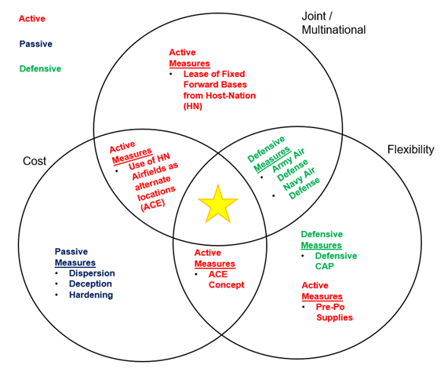

*Figure 1 The Solution Space depicting the relationship between the solution characteristics and the solution types*

The gold star represents the best theoretically possible solution, but may not exist in practice. There is a long history of inter-service rivalry that makes joint cooperation hard to accomplish as depicted in (insert source here). Multinational cooperation can also be considered quite fickle, outside of the countries with deep security ties to the United States already (Japan, South Korea, Australia).

# Why Shell-Game?

Shell Game, as a deceptive measure, is characterized as low-cost circle in Figure 1. However, if a theoretical case can be proven towards its effectiveness, the Shell Game Solution can be upscaled to multiple locations, including joint and multinational installations as a multiple of its relatively cheap cost. It has the potential to be at the intersection of the 3 characteristics of the solution space, the gold star location.

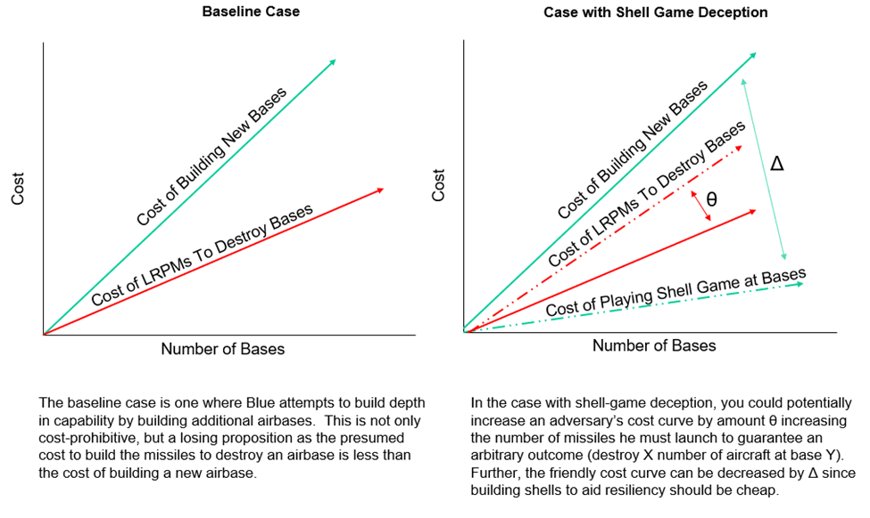

The promise of shell game is that it is a potential cost-imposing strategy where the friendly cost of playing shell game can only be mitigated by the more expensive action of building and deploying more missiles in an attack to achieve a baseline expected outcome.

# Conduct of the Research

First, we’ll presume a certain fixed number of shells are built on a single base for the shell game. The friendly force can put either an aircraft, a fuel bladder, or nothing underneath each shell. Additionally, the enemy will launch a number of missiles at the shells. Using a Monte Carlo simulation, the outcomes will be measured. The number of aircraft, number of fuel bladders, and number of missiles are defined by a discrete range of values, and full enumeration is used to develop the response surface of interest. Decoys and associated costs of assets of assets are not included in the first set of experiments.

The first study revealed an almost flat response surface in terms of the number of surviving aircraft. This was not wholly unexpected since the factors that drove the probability of a missile hit or miss was the number of missiles fired in the Monte Carlo versus the number of aircraft hidden underneath the shelters.

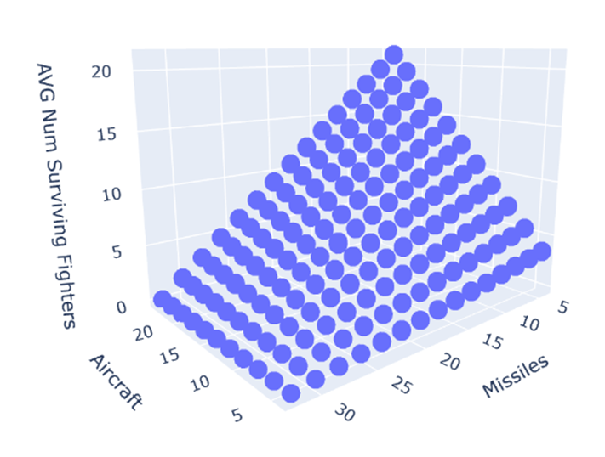

Similarly, missed percentage of missiles was looked at and followed an uninteresting linear relationship between the number of assets hidden under the shells and the miss percentage.

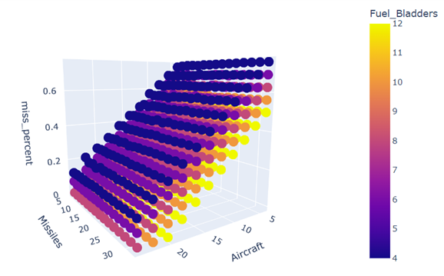

These response surfaces show that any strategy in deception can be countered by launching more missiles at the modeled base. Or, any deception strategy can be brute force defeated by launching an overwhelming number of munitions.

Given any deception strategy can be overwhelmed by an overwhelming missile attack, what happens if the enemy treats their missiles as scarce resources? This is not an outrageous assumption, as a missiles take time to produce. One could assume that the missile attack might be the opening act of a conflict, but missiles must be preserved for future use.

This leads to the modeling assumption that the enemy will try to match missiles to aircraft at the base.

In the second iteration of this model, we assume instead that the enemy will launch the same number of missiles at an airbase equal to the number of fighters present at the airbase. This can be thought of as the enemy has some way to accurately estimate the number of fighters present (by perhaps observing some proxy activity) but cannot observe which aircraft are parked under which shells. Number of shells remain constant, the number of aircraft on the airbase is varied, and the missiles launched equals exactly the number of aircraft on the airfield.

What was discovered was that if a Commander wanted to maximize the number of surviving aircraft available for post-attack sorties, then he could do so by using a ratio of 1 aircraft to every 2 shells on the airbase.

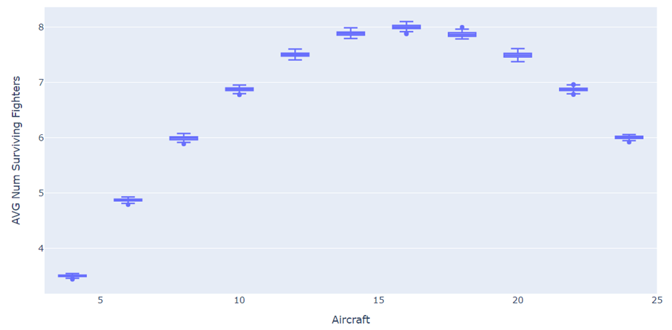

Additionally, under the aircraft = missiles assumption, one could potentially build back-up fuel capacity by placing fuel bladders underneath some of the shelters.

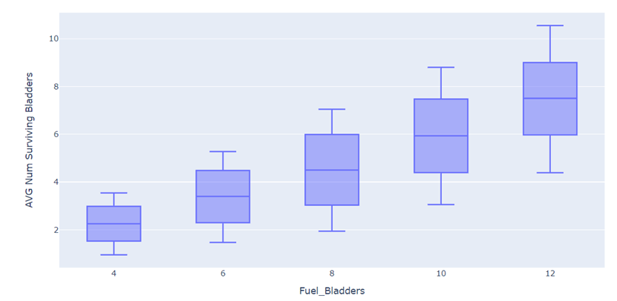

For the third iteration of this experiment, we embellish the model with a friendly strategy to encourage uncertainty and then model the enemies uncertainty of successfully guessing the number of aircraft located at the airfield.

The third iteration runs in the following steps:

1. The friendly side sets the number of aircraft at that base according to a uniform distribution.
2. The enemy side collects intelligence to estimate the number of aircraft and their location on the airfield for targeting. The equation that governs this step is:
3. Then, Monte Carlo simulation is used to generate the outcomes of the experiment, e.g. how many missiles were fired at the aircraft, how many aircraft are destroyed, etc.

The assumption of scarce missiles remains in place in that the number of missiles fired at the aircraft equals the perceived number of aircraft at the airbase. We assume that 32 shells are built that can hide up to 24 aircraft and that the shells offer no protection against missiles and only serve to “hide” the aircraft from overhead observation.

In this way, we can generate results that show the distribution of outcomes of interest.

The friendly strategy can be typified by the uniform distribution depicted below. This is tantamount to an operating posture that maintains a minimum of eight aircraft at an airbase, but the entire squadron can be dispersed over some area that includes airbases not modeled here.

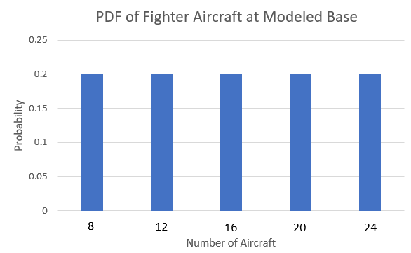

The enemy ability to target those aircraft is modeled in four different ways as depicted below. In the first scenario, we presume a relatively tight distribution of the possible modifiers. The enemy guesses correctly the number of real aircraft at the airbase half of the time, and either under or overestimates the number of aircraft half of the time.

In the second pdf, we assume that a squadron can deploy effective decoy aircraft at the airfield. This has the effect of creating dispersion in red’s estimation of the number of aircraft truly on the airfield.

For the final two pdfs, we assume that it’s possible to operationalize the shell game with decoys in such a way that blue can cause red to either consistently overestimate the number of aircraft (i.e. High-end bias) or consistently underestimate the number of aircraft present at the airbase (Low-end Bias).

Question: Can we induce a higher miss percentage from the higher enemy force?

Answer: Yes, but only at a relatively low number of aircraft present on the base.

Question: Can we reduce the number of aircraft destroyed in a given missile attack?

Answer: If we can induce the enemy force to fire less missiles, then we potentially can reduce the number of fighter hits.

Question: Is there a way I can maximize the number of fighters I have to retaliate post-attack, just considering the fighters I have on the single main base?

Answer: Yes, but it requires both risking more fighters at the main base and inducing the enemy to make low-biased guesses. Given the cost ratio between fighter aircraft and cruise missiles, this COA might not be considered appetizing.

Question: Can I induce the enemy to waste missiles?

Answer: Yes, if one reduces the number of aircraft actually at the base while simultaneously inducing the enemy to have a high-end bias.

**Insights from the 1st Model**

1. If my goal is to induce the enemy to waste missiles (i.e. maximize missile misses), then I can adopt a force posture of having relatively few aircraft at a base while operationally inducing the enemy to overestimate the number of aircraft I have at the base
2. If my goal is to maximize the aircraft I have immediately available for a retaliation strike, then I can do this by posturing aircraft forward at the base under study and operationally induce the enemy to underestimate the number of aircraft I have at the base. However, this COA is subject to the enemy also knocking out the runway and other necessary facilities for sortie generation.
3. If the goal is to minimize the number of aircraft destroyed on the ground in a missile attack, then the policy would be to keep as few aircraft at the attacked base as possible, with the majority of the aircraft deployed to some other place under the ACE concept. Of course, this is also contingent on keeping hidden the location of those wayward aircraft in theatre.
4. No amount of strategy can account for the possible enemy action of an overwhelming missile strike. In such a scenario, there isn’t a way to counter with deception or other means the destruction of all the aircraft present.

**Follow on Questions from 1st Model**

Okay, your model results point to two things: I need to induce the enemy to be judicious with his missiles somehow, and also think about how I can throw off the accuracy of his intelligence estimates. How might you do that?

So maybe the main storyline is about the decoys. Can a model be built that shows the cost effectiveness of decoys vs. shells (i.e. sunshades) vs. PAS vs. HAS and how many I should buy?

**Building the 2nd Model**

Step 1: We assume a fighter squadron of 24 aircraft and that aircraft will be parked under shelters if they are available.

Aircraft = 24

Open = Aircraft – HAS – PAS - SUN

Step 2: Full enumeration of the following inputs:

HAS, PAS, SUN, DECOY ϵ (0: 24)

Where:

HAS = # of Hardened Shelters

PAS = # of Protective Shelters

SUN = # of sunshades (Concealed parking but offers no protection)

DECOY = # of decoy aircraft.

Step 3: Estimate Cost of the fully enumerated COAs

Cost = 7.8*HAS + 3.6*PAS + 0.4*SUN + 0.1*DECOY

Step 4: Estimate P_K for each COA where

Where:

P_k = overall probability the aircraft is destroyed

P_ID = overall probability that the enemy correctly guesses the aircraft location

This is valid because aircraft are always placed in shelters when available. This is essentially random guessing where # of missiles = # of true aircraft but locations are ambiguously when there are a lot of decoys and/or a lot of shelters.

P_Damage = The probability that a missile attacking an aircraft under shelter overcomes the protection of the shelter and destroys the aircraft.

P_Damage is estimated as a weighted average.

Step 5: Once P_K is estimated, find Delta P_K and Cost Effectiveness:

Delta_P_K = 1 – P_K # valid because we start at the assumption P_K is 1

` Cost Effectiveness = Delta_P_K / Cost

This Deterministic model results in the following table, sorted by Cost Effectiveness:

This shows that Delta P_K is dominated by the use of decoys to the maximum level.

$189.6 mil is 24 HAS + 24 Decoys and is max delta p_k at 0.9

To the right of that is more expensive options. (with additional shelters). Those options are less effective because of how P_K is estimated (weighted average). The estimated P_K goes up with the addition of PAS and sunshade shelters, and is not offset enough by the decreasing P_ID of the increasing number of shelters.

$189.6 mil: 24 HAS + 24 Decoys p_k = 0.9

$2.4 mil: 24 Decoys p_k = 0.5

Zooming in, you can see the top edge of Delta P_K is dominated by the 24 decoy solutions, especially in the lower left hand corner.

**Insights**

Assuming you can build really good decoys for $100k and operationalize your deception such that they are indistinguishable from real aircraft, then decoys are far and away the best measure one can use to promote survivability of the aircraft on a single airfield, with number of missiles comprising the attack being constant.

**Recommendations**

Further studies, but on the classified side, should evaluate how to operationalize deception concepts that are centered around decoys.

Additionally, this study assumes a unit cost of $100k for the appropriate decoys, which was rounded up from the $80k for standard air-inflated decoys that are good visually, but perhaps not suited to fool other types of potential sensors surveying the pacific (such as synthetic aperature radar). Cost estimates could be done to estimate the development and procurement of an all-sensor fooling ground decoy aircraft.

Because a unit cost of $100k for an assumed decoy is so cheap, its possible to saturate the pacific theatre with them and they could be deployed to multiple places. Compared to a multi-million dollar cost of an enemy cruise missile (for reference, a tomahawk cruise missile costs $1.5 million), decoys would be cheap.

If the actual cost of convincing decoys remains within the same magnitude of cost, then it’s possible to use them to force adversaries into a cost-imposing strategy where the adversary must accept a lower p_k per missile launched at aircraft or must build and use many more missiles to guarantee a desired result.

# References

Cozad, M., Engstrom, J., Harold, S. W., Heath, T. R., Lilly, S., Burke, E. J., . . . Grossman, D. (20223). *Gaining Victory In Systems Warfare.* Santa Monica: Rand Corporation.

Curtis E. LeMay Center. (2022, August 23). Air Force Doctrine Note 1-21.

Lynch, C., Costello, R., Heim, J. L., Karode, A., Mills, P., Tripp, R. S., & Vick, A. J. (2023). *Operational Imperative: Investing Wisely to Bolster U.S. Air Bases against Chinese and Russian Attacks.* Santa Monica: Rand Corporation.

Orletsky, D. T., Brown, J. S., Deblois, B., Mills, P., Norton, D. M., Brackup, J., . . . Guffey, R. (2023). *How Can the Mobility Air Forces Better Support Adaptive Basing?* Santa Monica: RAND Project Air Force.

Thomas, B., Amouzega, M. A., Costello, R., Guffey, R. A., Karode, A., Lynch, C., . . . Romano, D. N. (2015). *Project AIR FORCE Modeling Capabilities for Support of Combat Operations in Denied Environments.* Santa Monica: Rand Corporation.

Vick, A. J., Zeigler, S. M., Brackup, J., & Meyers, J. S. (2020). *Air Base Defense: Rethinking Army and Air Force Roles and Functions.* Santa Monica: RAND Corporation.

Wong, J. P., Mazarr, M. J., Beauchamp-mustafaga, N., Bohnert, M., Boston, S., Curriden, C., . . . Welch, J. (2022). *New Directions for Projecting Land Power in the Indo-Pacific.* Santa Monica: Rand Corporation.